# Team Profile

## Team Name

Red Panthers

## Personal information

### Anthony Brown

**Name:** Anthony Brown

**Student Number:** s3460996

**Hometown:** Caloundra, Australia

**Education:** University of Queensland, BA applied Science

**Current Job:** Home dad

**Quick Bio:**

My name is Anthony. I am one of the Red Panthers.

My interest in IT started when I was doing data analysis for my work with Parks and Wildlife. I found solutions to both research questions and business administration were best provided by IT knowledge. I have pursued my career and continued to find IT as the solution to the problem my managers asked me to solve. Over time, almost as if by accident, I have collected a gaggle of hardly related IT skills and knowledge. Study at RMIT is a way for me to bring these together and – hopefully – raise myself up to a better level.

### Timothy Damon

**Name:** Timothy Damon

**Student Number:** S3829497

**Hometown:** Wonthaggi, Vic

**Education**: Year 12 (2013), Cert III in Retail and Hospitality (5 units of each), Test and Tag Cert.

**Quick Bio:**

I Developed an interest in IT at a young age through video games and expanded my interest through using various types of computers and discovering what they can do.

Recently was able to build my first PC after being interested in doing it for so long, this sparked a further interest in the more "behind-the-scenes" workings of IT.

My IT experience is limited mostly to fixing minor issues for family and friends, but also includes imaging 1000+ laptops with Windows for a local high school so that they could be used by the students.

My hobbies mostly include playing (and collecting) Video Games with my friends, browsing the internet (watching videos or reading interesting articles) and watching movies and TV shows.

### Shaun Lottey

**Name:** Shaun Lottey

**Student Number:** S3829826

**Hometown:** Sydney, Australia

**Education:** Trinity Catholic College, Class of 2007

**Current Job:** Driver/Storeperson

**Quick Bio:**

My name is Shaun and I am one of the Red Panthers.

I have had an interest in IT since a very young age. While I hold no formal qualifications nor have, I ever worked in the industry sector I have been tinkering with hardware and software since I was 5, starting with an (ancient by todays comparisons) Commodore 64.

In primary and high school, my friends and I would enjoy collecting second hand hardware components such as used server racks or PCs that our school had scheduled to be decommissioned and rebuilding them to our purposes.

From the ages of about 10 onwards, I began to experiment with programming using utilities such as RPGMaker or making custom mods for popular FPS titles such as Half-Life. I also learned a lot back then about HTML, PHP & SQL using it to develop and maintain online forums.

I also play guitar and enjoy playing online games with my friends, who are from all over the world.

### Jake McAndrew

**Name**: Jake McAndrew

**Student number:** s3818850

**Hometown:** Sydney

**Education:** Year 12

**Current Job:** Store man at Kmart

**IT Skills/interest:** Java, Cyber security

**Quick Bio:**

My name is Jake McAndrew, I’m 22 years old and have lived in Sydney all my life, but plan to someday move to Melbourne to explore new opportunities. I currently live at home with my parents and my twin brother who has very different interests to me and is pursuing a career in the military. I also have a sister who lives in Queensland who is a recently graduated medical doctor. I was born in Australia, but my family originally comes from Ireland and Scotland. Currently I can only speak English, but I would love to one day learn a new language, possibly Gaelic. Recently I started coding in java and loved it so much that I decided to make it my career, I now spend most of my free time coding to hone my skills. I have always been very passionate about all aspects of IT/Computer Science, but I’ve always had a particular interest in cyber security. I plan to use this degree as a launching pad into a computer science degree specializing in cyber security in the not too distant future. I like to spend most of my free time playing video games, coding in java, building computers, making music and lifting weights. I am currently a full-time employee at Kmart and have been for a number of years. I hope one day to leave my current job and obtain my dream career working as a cyber security expert.

### Jason Tilgner

**Name:** Jason Tilgner

**Student Number:** S3830312

**Hometown:** Yallourn North

**Education:** TAFE Certificates

**Quick Bio:**

Hi my name is Jason Tilgner , I am one of the Red Panthers.

My RMIT student number is S3830312. I live just outside of a country town called Yallourn North with my family and cat called Tyrion. I have been working in a few different IT positions over the last 10 years, and have also got a couple of different IT certificates. I am doing this course as I enjoy IT and also wish to progress my current career into software development or project management. My main hobby is I like to gym and also go to cross fit.

### Jason Walstab

**Name:** Jason Walstab

**Student Number:** s3291269

**Hometown:** Central Coast, Australia

**Education:** TAFE NSW Certificate IV in Networking

**Current Job:** Small business owner (www.quantumdata.com.au)

**Quick Bio:**

My name is Jason, but I usually go by Jay, and I am on the Red Panthers team.

I live in the “small”, quiet city of NanJing (population around 11.5 million) in China, with my wife and son and have done for the last decade or so.

I have always had a great interest in IT, and I have been working in the industry since I was 18. I started off in helpdesk, moved to sys admin and then on to work on CT machines (Philips Brightview XCT systems) and finally started my own IoT company here in China. I have made IT my life and will continue to follow that path, hoping this degree will help along the way.

I have worked with many different IT technologies, but now I mainly focus on NodeJS, ESP-32 micro-controllers and Linux cloud server management. I hope to one day return to Australia and get a full-time job in programming one day so I can spend more time with my family.

I have many hobbies which are electronics, programming, surfing, motor bikes the gym and recently have been getting into digital art as well as game design. I have spent many years learning language and now speak mandarin Chinese at a fluent (enough) level, maybe at the expense of my English though...! I spend most of my free-time spending time with my son and wife and going out with friends and have a comfortable but busy life here.

## Team Profile

#### Summary

The Red Panthers team is dominantly analytical types who are endowed with intellectual gifts but lacking the innate skills for keeping a team glued together. However, we have a couple of characters with natural gifts in leadership and communication. These fill the void and present a real opportunity for a group of individuals to come together and achieve goals.

The functional quirkiness of this group shows through in all the tests the group has undertaken but best illustrated by a comparison of the Myers Briggs results. The discussion below focuses on the Myers Briggs, as any insight from the other tests is hard to articulate (mostly because they are all different tests) and doesn’t offer any greater insight than the Myers Briggs alone.

The table below illustrates the tests undertaken by the Red Panthers

###### TABLE: Red Panthers Personality Tests

|  |  |  |  |
| --- | --- | --- | --- |
| **Member** | **Myers-Briggs (type and type description)** | **Test 2 (test Name and result)** | **Learning style** |
| Anthony Brown | INTP | DISC profile | Tactile Learner |
|  | Logician | Factfinder |  |
|  |  |  |  |
| Tim Damon | INFP-T | Big five personality test | Auditory Learner |
|  | Mediator | too difficult to summarise in a table |  |
|  |  |  |  |
| Shaun Lottey | ENFJ-A | Creativity Test | Auditory Learner |
|  | Protagonist | creativity level is: High |  |
|  |  |  |  |
| Jake McAndrew | INTJ | Big five personality test | Auditory/Visual Learner |
|  | Architect | too difficult to summarise in a table |  |
|  |  |  |  |
| Jason Tilgner | INTJ | Colour test | Visual Learner |
|  | Architect | too difficult to summarise in a table |  |
|  |  |  |  |
| Jason Walstab | ENTP-T | Creativity Test | Visual Learner |
|  | Debater | creativity level is: High |  |

#### Myers Briggs Comparison

The test site 16personalities (link <https://www.16personalities.com/personality-types>) groups Myers Briggs personality types (type) into four groups (role): Analysts, Diplomates, Sentinels and Explorers. Within each role is four types. Each type has an emotive name that illustrates the nature of that type. The diagram below shows the Myers Briggs matrix, and the counts are how the Red Panthers arrange within this sphere.

###### TABLE: The distribution of Red Panthers within the Myers Brigg Matrix of Possible results (with roles illustrated)

ISTJ ISFJ INFJ INTJ

ISTP ISFP INFP INTP

ESTP ESFP ENFP ENTP

ESTJ ESFJ ENFJ ENTJ

Analysts,

1 Logician

2 Architect

1 Debater

Diplomats

1 Mediator

1 Protagonist

Sentinels

Explorers

First off, what is a Protagonist? And, do we even need one of these? Turns out, yes, Protagonists are natural leaders, which every team needs. They are tormented souls with a natural empathy that others find authentic, even charismatic – the building blocks of a great leader. Like in a novel, one Protagonist is about the right number.

More obviously, we are a group composed of Analysts and Diplomates but no Sentinel’s or Explorers. The question is; are we a lesser team for not having Sentinels or Explorers? Explorers are risk-takers that do their work fast and well, though easily distracted. They seem very useful but irritating. Sentinels on-the-other-hand are hard-working administrators. Sentinels are another type any team would benefit from having. In fact, these two roles together could be a power team in their own right – like Matthew McConaughey and Kate Hudson in *Fools Gold*.

Can we get by without these two amazing personalities contributing to our cause? A closer look at the types we have should answer this. We are strong in analyst, with three out of four types covered. We also have an additional Diplomat. Alongside our Protagonist (already discussed) we are doubly blessed to have a Mediator. Like unicorns, Mediators are rare – and magical. Mediators come loaded with talents amiable to working in teams: principled, able to genuinely connect with people and understanding of their place as part of the whole. To be at their best, a Mediator need to keep their energy levels high, so leadership and administrative help are vital.

The core of our group is a cohort of Analytic types – not surprising for an IT degree. Analysts are excellent strategic thinkers, but not so good when it comes to social or romantic pursuits. Luckily, we are all dudes. Jokes aside, the Red Panther is confronted with the inescapable truth; we have the intellectual horsepower to deal whatever is before us, but our awkward, prickly selves might be the iceberg to our teamwork titanic.

A balanced team we are not. We have a severe lean towards the Analyst pole, with nothing balancing the team from the spontaneous and neatly arranged Explorer and Sentinel roles. On the bright side, the Red Panther’s edges are more than smoothed out with the serendipitous inclusion of two enigmatic representatives from the Diplomatic roles. A Protagonist brings leadership qualities and our Mediator comes with a cornucopia of team-binding instincts.

We must stay vigilant to the near and present dangers of not sticking together as a group. We should let the fundamental skills within take root. Achieve this, and we can be as good as any IT department has ever been. Although, a Kate Hudson type would be an inclusion worth head-hunting.

## Ideal Jobs

Our group picked ideal jobs across a few different areas of information technology, most of the group wishes to eventually end up in the programming field in different sub areas. Such as gaming programmers or stack developers. Tim is interested / ideal job is being a senior game player designer, Shaun has expressed an interest in being a senior C++ engineer / Game play programmer, Jake’s interest is in being a software developer, Jason T has an interest in being a full stack developer, Anthony’s expression of interest is also in being a full stack developer, and Jason S is interested in being an IOT (internet of things) solutions team leader.

As most of the group is interested in software development / programming some of the skills needed amongst the group are very similar in the programming job roles. Some of these skills include understanding of programming languages, level of understanding of using text editors to produce code, the ability to work well in a small team, and the ability to adapt to new technology quickly. These skills are the same and needed regardless of the area of programming our group is wishing to enter. As every programmer needs to understand the code for the application they are writing, every programmer needs a tool to produce code, and most programming teams are not overly large. The common element among our team group is that we want to end up in programming - even Jason S who wishes to be an IOT solutions team leader, so members of the group has very similar career pathways. Another common factor among our group is most of us have a requirement to learn C++.

While the common theme amongst our group is a career in programming, we have expressed interests in different areas of programming. Our diverse interests include games programming, web programming, business application development and IOT knowledge. The obvious differences in our chosen jobs is that the platforms you use in one field is not use in another. For example, you could ‘unity’, used for game creation, for building business applications. The members of our group will need to develop skills and knowledge in different platforms, languages and tools. Another difference is, for the two members who have selected stack development as their ideal roles, they will need to gain experience with several tools or languages. This could include Java, C sharp, CSS.

The group does have a lot of key similarities in our main areas of programming and in IOT knowledge. But because we are interested in different fields, there are some differences in the tools and experience required for each chosen job. This will also help process our group along as we are interested in the same / similar things.

# Tools

## Link to the Red Panther web site

https://ittgroup14.github.io/assignment2/

## Link to the Red Panther git hub

https://github.com/ittgroup14/assignment2

## Link to the Red Panther Trello

https://trello.com/invite/b/aRNDaLjO/572786522c71743ed9600bc041707a0f/assignment-2

## Tools discussion

We, the Red Panthers made great use of four main communications tools: GitHub, Trello, Discord and Slack.

These tools have really been the backbone for this group and have allowed us to work as a team regardless of distance or time zones. We believe that, without these tools the work would not have been possible. We all feel that what went well was the setting up of these tools from the start to ensure everyone could follow along and contribute as necessary. This allowed us to establish as clear workflow structure that we could all follow.

The contributions started with those most familiar with the technology. As the project progressed, members that had not used them much before became most relaxed and began contributing in their own name, instead of having others lodge on their behalf. This evolution is reflected in the commit history on GitHub.

# Industry Data

## Demand for Red Panther’s Job Titles

|  |  |
| --- | --- |
| **Member** | **Job title** |
| Anthony Brown | Full-Stack Developer |
| Tim Damon | Senior Gameplay Designer |
| Shaun Lottey | Senior C++ Engineer (Gameplay Programmer) |
| Jake McAndrew | ASD Software Developer/cybersecurity |
| Jason Tilgner | developer / full stack developer. |
| Jason Walstab | IoT Solutions Leader |

### Consideration of what the Burning Glass list of job titles is presenting

The burning Glass data ranked by count of job descriptions advertised across a year. We see some problems with this data. Once smoothed out and accounted for the figures reflect a different outcome. We have explained this below, then looked at how the Red Panthers dreams are reflected in the job market.

#### Data adjustments

In considering this data and our future career aspirations, we see three issues that must be address:

1. Ranking is misleading
2. Job titles have not been compiled into homogeneous groups
3. Salaries are not considered

We discuss each in turn.

##### Ranking

Firstly, the current listing is also overly dramatic. The difference between counts for some descriptions is inconsequential. Looking at the graph you might think job A is in more demand than job B because it is one step higher in the rank, but this isn’t so. The difference in counts are somewhat inconsequential. In other words, a great number of these jobs should be ranked on the same tier because their counts are more-or-less the same. We did this by converting the counts to a percentage of the total, then ranking by base points (first decimal of the percentage). Ranking cells changed from 200 to 24. See TABLE1.

Looking at this new arrangement; we see the top 50% of job counts are within the range of 1%-3%, which is very close to each other. We wonder, for half the jobs listed, if this ranking is insightful at all.

##### Join like jobs together

The second issue is that job titles have not been well combined. The job ‘System Architect’ looks like the most in-demand job, but below we will disprove this.

We searched for job titles that contained the word ‘desk’ and found a mass of related roles. The different job names reflect more the changing trends in job titles, less the change in job role. A count of 16 job titles was returned with a sum of 2000 ads, making this by far the most prolific job placements at 6% of the total. The job descriptions also give us hope that there is a considerable opportunity for career progression within this bracket. See TABLE 1a.

Similarly, front-end developer positions look small, but after accounting for variations in naming the count becomes healthy. Together, jobs containing the term ‘front’ sum to 1197 job placements. At 4% of the total, a substantial lead on ‘Systems Architects’. See TABLE 1b.

##### Salary

The other thing entirely missing from this approach is salary. There may have only been 50 IT Security Analyst listed in the last year, but say their salary is $250K annually, you might well want to have you sights on this, in the long run. You cannot get to these big paying jobs in quick steps, you must build a career towards them. But what are they?

### Looking at Jobs Titles within Red Panther

Within our group, there are four types of jobs we are interested in pursuing.

* Full-stack developer
* C++ Engineer (Gameplay Programmer)
* Cyber-security
* IoT engineer

Full-stack developers should have developed skills in front end and back end frameworks. We accumulated a list of front-end, back end, cloud and database type roles that are encompassed by the term ‘full-stack’. The total is 2750 job adds. At 9% of all listings, this is a healthy line of business. See Table 2.

General variants on the developer theme, and outside of those already counted, totalled 6030 jobs (around 20%) Table 3.

Gameplay and C+ engineers have few listings. There are no Game developers and only 90 C language positions.

Cyber-security. Looking for jobs containing ‘security’ returns a list of 900 jobs. At 3% of the total, this too is a big hitter, and with options for career progression - Table 4.

The is nothing in the list for IoT engineer, making it a boutique line of work.

### Jobs Titles graphs

TABLE1: a less dramatic way to rank Job title advertisements

|  |  |  |  |
| --- | --- | --- | --- |
| **Rank** | **percentage of total jobs listed** | **Count of Job titles** | **Sum of Job Postings** |
| 1 | 0.033 | 1 | 987 |
| 2 | 0.03 | 1 | 887 |
| 3 | 0.027 | 1 | 808 |
| 4 | 0.026 | 2 | 1565 |
| 5 | 0.025 | 1 | 738 |
| 6 | 0.024 | 1 | 713 |
| 7 | 0.023 | 1 | 681 |
| 8 | 0.022 | 1 | 666 |
| 9 | 0.019 | 1 | 555 |
| 10 | 0.018 | 1 | 539 |
| 11 | 0.016 | 3 | 1423 |
| 12 | 0.013 | 2 | 752 |
| 13 | 0.012 | 1 | 344 |
| 14 | 0.011 | 4 | 1327 |
| 15 | 0.01 | 1 | 303 |
| 16 | 0.009 | 4 | 1101 |
| 17 | 0.008 | 6 | 1401 |
| 18 | 0.007 | 3 | 649 |
| 19 | 0.006 | 10 | 1775 |
| 20 | 0.005 | 13 | 1926 |
| 21 | 0.004 | 25 | 2885 |
| 22 | 0.003 | 34 | 3017 |
| 23 | 0.002 | 70 | 4065 |
| 24 | 0.001 | 13 | 562 |
| **Grand Total** | | **200** | **29669** |

TABLE 1a: Work in the Help service sphere

|  |  |
| --- | --- |
| **Title** | **Job Postings** |
| Service Desk Analyst | 779 |
| Desktop Support Analyst | 164 |
| Desktop Support Engineer | 162 |
| Desktop Support | 127 |
| Service Desk Officer | 112 |
| It Service Desk Analyst | 108 |
| Help Desk Analyst | 95 |
| Desktop Support Officer | 92 |
| Help Desk Officer | 58 |
| Service Desk Consultant | 57 |
| Desktop Engineer | 56 |
| Help Desk Support | 52 |
| Service Desk Technician | 51 |
| It Help Desk Support | 47 |
| Service Desk | 46 |
| It Help Desk | 42 |
| **TOTAL** | **2048** |
| **Pct** | **7%** |

**TABLE 1b: positions including the name ‘full’**

|  |  |
| --- | --- |
| **Title** | **Job Postings** |
| Full Stack Developer | 344 |
| Full Stack Java Developer | 115 |
| Full Stack .Net Developer | 113 |
| Senior Full Stack Developer | 98 |
| Full Stack Web Developer | 49 |
| **TOTAL** | **719** |
| **Pct** | **2%** |

TABLE2: Roles available for full stack developers

|  |  |
| --- | --- |
| **Job title** | **ad counts** |
| Full-Stack Developer | 344 |
| Full Stack Java Developer | 115 |
| Full Stack .Net Developer | 113 |
| Senior Full Stack Developer | 98 |
| Full Stack Web Developer | 49 |
| Front End Developer 1 | 738 |
| Senior Front End Developer | 303 |
| Front End Web Developer | 85 |
| Frontend Developer 2 | 71 |
| Cloud Engineer | 65 |
| Cloud Architect | 58 |
| Database Administrator | 238 |
| Data Engineer | 182 |
| Data Architect | 162 |
| Data Administrator | 82 |
| Data Warehouse Developer | 44 |
| **TOTAL** | **2747** |
| **Pct** | **9%** |

TABLE 3: roles for developers

|  |  |
| --- | --- |
| **Title** | **Job Postings** |
| .Net Developer | 808 |
| Java Developer | 713 |
| Senior Net Developer | 481 |
| Senior Java Developer | 478 |
| Software Developer | 337 |
| Developer | 278 |
| Php Developer | 277 |
| Senior Developer | 243 |
| Ios Developer | 227 |
| Senior Software Developer | 178 |
| Android Developer | 171 |
| Senior Php Developer | 143 |
| Senior Ios Developer | 119 |
| Javascript Developer | 113 |
| Python Developer | 106 |
| Integration Developer | 101 |
| Ruby On Rails Developer | 99 |
| Etl Developer | 94 |
| Application Developer | 92 |
| Drupal Developer | 89 |
| Mobile Developer | 82 |
| Mobile Applications Developer | 76 |
| Senior Android Developer | 72 |
| Sap Abap Developer | 69 |
| Hadoop Developer | 66 |
| Junior Developer | 66 |
| Lead Developer | 61 |
| Junior Net Developer | 58 |
| Mid-Level .Net Developer | 54 |
| Salesforce Developer | 50 |
| Graduate Software Developer | 48 |
| Senior Drupal Developer | 48 |
| Oracle Developer | 47 |
| Aem Developer | 44 |
| .Net Web Developer | 42 |
| **TOTAL** | **6030** |
| **Pct** | **20%** |

TABLE4: Roles available in the security field

|  |  |
| --- | --- |
| **Title** | **Job Postings** |
| Security Analyst | 173 |
| Security Architect | 142 |
| Security Consultant | 107 |
| Information Security Manager | 91 |
| Senior Security Consultant | 73 |
| Network Security Engineer | 72 |
| Security Engineer | 70 |
| Information Security Consultant | 59 |
| Information Security Analyst | 58 |
| It Security Analyst | 51 |
| Security Manager | 50 |
| **TOTAL** | **946** |
| **Pct** | **3%** |

## Demand for Red Panther’s Skill Sets

**Anthony Brown:**

**Ideal Job:** Full Stack Developer

**General Skills Required:** Communication skills, problem Solving, organisational skills, creativity, planning, detail orientated, time Management, troubleshooting, meeting deadlines, multi-tasking, English, self-starter and decision Making.

**IT Skills required**: Experience with .net/.net core, C#, Javascript, HTML, CSS React and Angular.

**Tim Damon:**

**Ideal Job:** Senior Gameplay Designer

**General Skills Required**: Communication Skills, problem solving, writing, teamwork/collaboration, planning, leadership, meeting deadlines, mentoring, English, decision making.

**IT Skills required:** Knowledge of scripting and basic programming.

**Shaun Lottey:**

**Ideal Job:** Senior C++ Engineer (Gameplay Programmer)

**General Skills Required:** Problem solving, detail-orientated, analytical skills, teamwork/collaboration, planning, leadership, meeting deadlines, mentoring, troubleshooting.

**IT Skills required:** Strong C++ skills, experience using game development engine “Unreal Engine 4”.

**Jake McAndrew:**

**Ideal Job:** Australian Signals Directorate (ASD) Software Developer

**General Skills Required:** Problem solving, troubleshooting, teamwork/collaboration, troubleshooting, detail-orientated, analytical skills.

**IT Skills Required:** C/C++/C#, Assembly languages, Python, Linux, mobile device debugging and software security analysis.

**Jason Tilgner:**

**Ideal Job:** Full Stack Developer

**General Skills Required:** Communication skills, problem Solving, troubleshooting, organisational skills, creativity, planning, detail orientated, time Management, meeting deadlines, multi-tasking, English, self-starter and decision Making.

**IT Skills Required:** HTML, CSS, JavaScript, React, Python and Agile.

**Jason Walstab**

**Ideal Job:** IoT Solutions Leader

**General Skills Required:** Communication skills, analytical skills, problem solving, management, leadership, organisational skills, creativity, planning, detail orientated, time management, meeting deadlines, multi-tasking, English and decision Making.

**IT Skills Required:** Experience with micro-computers/electronics, API’s and cloud platforms (Amazon Web Services and Azure).

**Group IT Skills:** Net/.net core, C#, C++, C, JavaScript, HTML, CSS, React, Angular, knowledge of scripting and basic programming, experience using game development engine “Unreal Engine 4”, Assembly languages, Python, Linux, mobile device debugging and software security analysis, JavaScript, Python and Agile, Experience with micro-computers/electronics, API’s and cloud platforms (Amazon Web Services and Azure).

**How do the IT-specific skills in your required skill set rank in terms of demand from employers?**

The top IT skills in demand for 2020 are currently SQL, Java, Python, Linux, JavaScript, Amazon Web Services (AWS), C, C++, C# and .NET (Florentine, 2020). From our group's ideal jobs skills breakdown, we can see that most of us fall into the in-demand skills.

Anthony Brown’s skills contain two of the most in demand skills, .NET, C# and JavaScript skills. Unfortunately, Tim Damon does not fall into any of the top demanded skills from employers. Shaun Lottey has currently one IT skill in demand, C++ skills. Jake McAndrew has four of the most in demand skills, C++, C, Python and Linux. Jason Tilgner also does not fall into any of the top demanded skills by employers. Jason Walstab has only one of the most in demand skills, AWS (Amazon Web Services)

As a Group we cover eight out of ten (%80) of the most in demand skills by employers.

**What are the three highest ranked IT-specific skills which are not in your required skill set?**

The three highest ranked IT specific skills that are not in our skill set are: SQL, Java with our C skills and Amazon web services being tied for third place as our skills in these areas are rather weak with only one member respectively having one of these skills each.

**Group General Skills:**

Communication Skills: 4/6 members in our group have communication skills as an important skill for their ideal job.

Problem Solving: 6/6 members in our group have problem solving as an important skill for their ideal job.

Organisational Skills: 3/6 members in our group have organisational skills as an important skill for their ideal job.

Writing: 1/6 members in our group have writing as an important skill for their ideal job.

Teamwork/Collaboration: 3/6 members in our group have teamwork/collaboration as an important skill for their ideal job.

Troubleshooting: 5/6 members in our group have troubleshooting as an important skill for their ideal job.

Planning: 5/6 members in our group have planning as an important skill for their ideal job.

Detail-Orientated: 5/6 members in our group have being detail-orientated as an important skill for their ideal job.

Creativity: 3/6 members in our group have creativity as an important skill for their ideal job.

Research: No members of our group have research as an important skill for their ideal job.

Leadership: 2/6 members in our group have leadership as an important skill for their ideal job.

Time Management: 3/6 members in our group have leadership as an important skill for their ideal job.

Quality Assurance and Control: No members of our group have quality assurance as an important skill for their ideal job.

Presentation Skills: No members of our group have presentation as an important skill for their ideal job.

Meeting Deadlines: 5/6 members in our group have meeting deadlines as an important skill for their ideal job.

Analytical skills: 3/6 members in our group have analytical skills as an important skill for their ideal job.

Team Building: No members of our group have team building as an important skill for their ideal job.

Multi-Tasking: 3/6 members in our group have multi-tasking skills as an important skill for their ideal job.

English: 4/6 members in our group have English skills as an important skill for their ideal job.

Building Effective Relationships: No members of our group have building effective relationships as an important skill for their ideal job.

Articulate: No members of our group have articulation skills as an important skill for their ideal job.

Self-Starter: 2/6 members in our group have being a self-starter as an important skill for their ideal job.

Decision-Making: 4/6 members in our group have being a decision making as an important skill for their ideal job.

**What are the three highest ranked general skills which are not in your required skill set?**

The three highest ranked general skills that are in our skill set are: Research skills, quality assurance and control skills and presentation skills.

Florentine, S. (2020). *Top 10 technical skills that will get you hired in 2020*. [online] CIO. Available at: <https://www.cio.com/article/3487724/top-10-technical-skills-that-will-get-you-hired-in-2020.html> [Accessed 10 Jan. 2020].

## Reconsidered Job Interests

### Anthony Brown Full-Stack Developer

I think a full-stack developer covers a broad range of skills that can generate a lot of opportunities in an IT career. I am happy to continue in this direction, as opportunities arise.

### Tim Damon Senior Gameplay Designer

As someone starting this course without a specific job goal post, more using the course to see which aspects of IT interest me, my ideal job was less of a goal and more of an interesting point that one of several paths could lead me too. As such my ideal job is not set in stone and is subject to constant change depending on which aspects I am finding most interesting. But an ideal job to me would be one that fits my interests, not one that appears to be most available; though it could happen that both end up true.

### Shaun Lottey Senior C++ Engineer (Gameplay Programmer)

### Jake McAndrew ASD Software Developer/cybersecurity

After looking at the data for jobs in the cyber security field, I feel a little underwhelmed with amount of jobs available. As of now, I am still very determined to work for the ASD as a Software developer because cyber security is my main passion when it comes to IT and I feel it would be a very rewarding career, but it may be harder to achieve then I initially thought. Looking at the data has also made me consider a fall back career as a java developer.

### Jason Tilgner developer / full stack developer.

### Jason Walstab IoT Solutions Leader

After looking at the data for jobs in the industry, the lack of specialized IoT jobs is not surprising. It is a relatively new field, although it is beginning to grow.

Another factor is that generally IoT jobs are also split into separate job titles. A network engineer is hired for the network side of things, a programmer for the programming, hardware engineer for hardware design etc.

This field is still a growing field and although the job market now doesn't reflect it, I still believe IoT specialist jobs will only continue to rise as the industry matures and I would continue to look at this career path for the future.

# IT Work

## Interview an IT professional

TODO

# IT Technologies

## Topic 1: small computing devices

### What do small computing devices do:

Small single-board devices like a Raspberry Pi, an Arduino or an ESP-32 are generally used in many applications. You will find them in appliances, factories, home-automation, network security, healthcare, robotics, education, hardware/invention prototyping and IoT applications. They can be used as regular computers but more often as controllers for electrical devices (everything from light bulbs, factory robotics, fridges to large commercial hot water systems). Generally, the use of one of these pieces of hardware would be to run a small script or program on the micro-computer, with its GPIO pins connected to whatever device and/or devices you would wish to control.

What these computing devices do is allow someone to use them as a computer to control the electrical signals sent to the GPIO pins. They have inputs/outputs to connect to sensors and information receive/send functions. The driving technological force behind these single-board computers has been the constant technological advancements in manufacture of smaller, more efficient, less costly computer parts. Specifically, smaller storage, CPU and ram.

An example of what a micro- computer would do in a home automation setup would be having a Raspberry Pi with a movement detector. The detector (or an ultrasonic distance detector) could see if someone or something is moving in view of the sensor. If movement is detected, a camera installed on the Pi can automatically begin recording. The video can be stored locally or remotely on a cloud server. A setup like this would not be expensive compared to the previous generation of commercial security camera setups. They required expensive DVR equipment and a central server to store video data.

Another example is to use micro-computer to report productivity in a factory. the ESP-32 micro-computer could be connected to a PLC control-board operating a conveyer belt. The ESP-32 could be programmed to send instructions to the PLC board using the ‘Modbus’ computer language through an open source software such as Node-Red. This ESP-32 could then be setup to create and send weekly reports of conveyor belt speeds to a server. The reports would give a rough assessment of productivity during the week.

An appliance example is use with a hot water system. An Arduino could be attached to a temperature sensor within the tank. The Arduino sends the sensor’s internal tank temperature records to a cloud server. The head company then accumulates statistics on how well their hot water systems are performing in the field. Using this kind of technology, a company would be able to detect trends over time and to a degree of accuracy that has not previously be achievable. Previously they would have sent an electrician/plumber to check numbers every time a tank is serviced, which is an additional labour cost avoided.

A final example is to improve network security by using a raspberry Pi as a remote VPN. Maybe you are a journalist/government employee/high corporate going to a foreign country where internet access is heavily restricted, and you need to send or view sensitive information over the internet. Before you leave, you could setup a Raspberry Pi at a secure location in your own country with an Open-VPN server, which you could then connect to remotely with an Open-VPN client when you have landed at your new location. This would allow you to have cheap access to a secure stable line that could not be viewed by a third party, such as a commercial VPN provider.

What these devices do is up to the person who is using it, as there are so many different uses and applications and the list is only growing as the technology matures.

### What is the likely impact of small computing devices:

I believe the likely impact of small single-board computers will be the computerization of many products that were previously not computerised or networked. The price point for single-board computers has been dropping considerably, especially over the last decade. This makes it more accessible for people to use single-board computers in their product designs/tech solutions.

The impact will especially be felt in the IoT sector, which is growing at incredible rates. The IoT market is fuelled by the rise of single-board computers such as the Raspberry Pi and Arduino and is expected to reach $1,102.6 billion US dollars by the end of 2026 (Fortunebusinessinsights.com, 2020). Due to the huge growth in this sector, we can expect to see this whole new industry around small single-board computers become a much bigger deal in the future as well as providing many new jobs, challenges, solutions and problems. The single-board computer market itself is expected to reach $1 billion US dollars by the end of 2025 (Global Market Insights, 2020).

Another impact will be especially felt in developing countries where small single-board computers have been at the heart of robotics development in Kenya, Africa. This has spurred a huge education drive towards programming, robotics and computers and will be one of the big driving factors of helping to develop these countries by providing jobs, industry and education to areas that were previously not able to access and work with high cutting-edge technology (The Star, 2020), (Fast Company, 2020).

With these developments in small single-board computing technology, even the future of national security may be impacted. In April 2018, America’s space agency NASA was attacked and comprised via the use of a $35 Raspberry Pi. As people's homes, workplaces and governments are increasingly connected and equipped with small single-board computers the risk of hacking and cyber-attacks may increase and cause many potential problems in the future (Forbes.com, 2020) , (CYBERSECURITY MANAGEMENT AND OVERSIGHT AT THE JET PROPULSION LABORATORY, 2019).

### How will small computing devices will affect people:

In daily life, I believe the affect it will have on me and others will be substantial. The idea of a computer being a large, bulky and expensive device is no longer a reality for the home consumer. If you want to watch movies, browse the internet or listen to music you can simply purchase a cheap single-board computer and plug it into any TV to do the trick. The rise of this cheap computing revolution will no doubt bring people who were previously not interested in tech into the fold as it becomes a part of daily life.

Privacy concerns will also arise. Small computer devices are all being networked and presumably connected to the cloud. People's homes will be more susceptible to attack through this gateway (WashingtonPost.com, 2020). This could affect myself directly, or indirectly (via my breach) my friends or family. With small computer devices, the need to stay diligent regarding cyber-security will be a necessity of everyday life. The need for everyday people to understand the basics of network security increases as these new technologies get implemented.

For us here studying IT at RMIT, the field of micro-computers is going to have a great effect on our careers. As people who are studying IT, or strive to work in an IT field, we should take an interest in the growing industry of IoT and single-board computers.

Electronics has been left on the wayside of IT skills for a long time now. But with the rise of single-board computers, there will also rise the IT specialists with the electronics skills to build and service them. A new specialty (or the re-emergence of an old one). Since the use of single-board computers generally requires a broad knowledge of IT, combing all aspects of previously separated fields such as hardware/networking/programming and electronics, this will be especially demanding of a broad knowledge base.

### References for small computing devices

Fortunebusinessinsights.com. (2020). Internet of Things Market Size, Growth | IoT Industry Report 2026. [online] Available at: https://www.fortunebusinessinsights.com/industry-reports/internet-of-things-iot-market-100307 [Accessed 10 Jan. 2020].

Global Market Insights, I. (2020). Single Board Computer Market to surpass $1bn by 2025: Global Market Insights, Inc.. [online] GlobeNewswire News Room. Available at: https://www.globenewswire.com/news-release/2019/02/13/1724445/0/en/Single-Board-Computer-Market-to-surpass-1bn-by-2025-Global-Market-Insights-Inc.html [Accessed 10 Jan. 2020].

The Star. (2020). Engineering students create wall climbing robot prototype. [online] Available at: https://www.the-star.co.ke/sasa/2019-07-26-engineering-students-create-wall-climbing-robot-prototype/ [Accessed 10 Jan. 2020].

Fast Company. (2020). Bringing The Maker Revolution To Africa, One Raspberry Pi At A Time. [online] Available at: https://www.fastcompany.com/3023170/bringing-the-maker-revolution-to-africa-one-rasperry-pi-at-a-time [Accessed 10 Jan. 2020].

Forbes.com. (2020). ExtraHop BrandVoice: What We Can Learn From NASA’s Raspberry Pi Attack. [online] Available at: https://www.forbes.com/sites/extrahop/2019/07/31/what-we-can-learn-from-nasas-raspberry-pi-attack/#13dcab7e304c [Accessed 10 Jan. 2020].

CYBERSECURITY MANAGEMENT AND OVERSIGHT AT THE JET PROPULSION LABORATORY. (2019). [ebook] NASA. Available at: https://oig.nasa.gov/docs/IG-19-022.pdf [Accessed 10 Jan. 2020].

WashingtonPost.com. (2020). Nest cam monitor hacked and kidnap threat came from device parents say. [online] Available at: https://www.washingtonpost.com/technology/2018/12/20/nest-cam-baby-monitor-hacked-kidnap-threat-came-device-parents-say [Accessed 10 Jan. 2020].

## Topic 2: Cybersecurity

### What does it do:

Recently, my Mum’s bank account was hacked. The company she shopped with did not have the right cybersecurity measures to keep her information safe and secure. My mum’s example illustrates how cybersecurity in a business – or more poignantly the lack of – can have a profound effect on the average person.

As our society becomes more and more dependent on computers and technology, the importance and need for cybersecurity has grown exponentially. Cybersecurity is such an essential piece of technology as a range of organisations including government, banks, medical facilities and companies (small and large) store an incredible amount of information. A significant portion of that information is extremely sensitive. Our society also has lots of specialty software and hardware that may not be available anywhere else in the world. Our dependent on computers and our advanced technology makes us a target for hackers and cybercriminals.

The absolute goal of cybersecurity is to prevent or limit the risk of a possible cyberattack. Cybersecurity must protect sensitive information from being accessed by unauthorised people, as well as protect other related vital pieces of IT. Without any form of cybersecurity, organisations and businesses will be left wide open for potential cyber-threats and cybercrime. In many countries, it is illegal for a large company to have no cybersecurity measures due to the large amounts of sensitive information they hold.

One of the major new technologies developed for cybersecurity is the use of Artificial Intelligence (AI). Cognitive computing, an advanced type of AI, is already being implemented worldwide by many cybersecurity firms. Cognitive computing uses many different types of AI technologies, such as machine-learning algorithms and deep learning networks, to analyse and learn from each threat it detects. This type of AI is an essential part of modern-day cybersecurity because it allows a better understanding of advanced threats and also enables a quicker and more decisive response to them.

The use of AI in cybersecurity allows IT professionals in the field to be more efficient. For example, experts may use AI to detect and gain information about each threat. The expert can then use the information to respond quickly and more appropriately to the threat. The AI acts like an advisor, of sorts, to the expert, effectively making the whole process quicker.

Technology grows at an extraordinary rate. Likewise, AI in cybersecurity is only going to become more prominent. In a survey conducted by the Capgemini Research Institute, 69% of organisations think AI is necessary to respond to cyber-attacks. And, three out of five firms said that using AI improves the accuracy and efficiency of cyber-analysts. This research supports the proposition that over the next few years, cybersecurity firms will continue implementing new forms of AI.

### What can be done now:

Right now, there are many ways to implement cybersecurity measures inside an organisation. These include; installing firewalls and implementation more encryption within the network. Businesses may hire cybersecurity experts and security analyst to help protect their assets against threats. Experts may seek and eliminate variabilities through such things as ethical hacking, or installing tools to monitor for intrusions, or indeed respond to security incidents. Cybersecurity experts are a vital part of the industry and any organisations, big or small, who are looking to protect themselves from cybercrime, should consider enlisting their aid.

### What is the likely impact:

Cybersecurity allows organisations to protect their most valuable assets. Cyber-crime has a major impact on the world today, and the cybersecurity industry has created numerous employment opportunities in response. It is a multibillion-dollar industry with a market value of more than $120 billion. As we develop more technologies, such as cognitive computing, hardware authentication and user-behaviour analytics, the market value will increase. The industry predicts the value of the sector will to grow to $300 billion by 2024.

Experts have conflicting views on the impacts of AI technologies on employment in the field. AI technologies have already started to replace workers in many industries such as healthcare, pharmaceutical research, retail and marketing. Many experts fear that this could also happen in the field of cybersecurity. Some disagree. Aaron Levie, chief executive of cloud storage service ‘Vendor Box’ once said “If you want a job for the next few years, work in technology. If you want a job for life, work in cybersecurity”.

Tech enthusiasts and some cybersecurity specialists believe that advancements in AI for cybersecurity will not remove cybersecurity jobs, but it will drastically change them. In the not so distant future, we could see humans and AI working together to complement each other. An example of this would be AI responding to a malware attack, quickly researching characteristics of the malware and recommended a course of action. AI relieves the analysts from any time-consuming manual research. In theory, this will speed the process of responding to a threat dramatically, then making the analyst’s job more enjoyable. Experts already working will have to upgrade their skills to keep pace with these new technologies.

### How will this affect you

A common misconception is that cybersecurity is something that only big organisations have to worry about. But in reality, cybersecurity has a profound effect on everyone who connected to the internet. As someone who likes to be protected when browsing online, these advancements in cybersecurity bring me peace of mind. We all must trust organisations with our private and sensitive data. It’s of utmost importance that they stay up to date with the current technologies to keep our information safe

Even though my family and friends do not know all that much about cybersecurity, the recent advancements are going to benefit them greatly. Now, and from here forth, anything is online. What happened to my Mum could happen to yours, or a small business, or a large corporation. Organisations need to invest in proper cybersecurity measures to protect themselves, their clients and our society.

## Cybersecurity References

Hashed Out by The SSL Store™. (2020). Artificial intelligence in cyber security: The savior or enemy of your business? - Hashed Out by The SSL Store™. [online] Available at: https://www.thesslstore.com/blog/artificial-intelligence-in-cyber-security-the-savior-or-enemy-of-your-business/ [Accessed 8 Jan. 2020].

SEEK. (2020). [online] Available at: https://www.seek.com.au/job/40673900?type=promoted#searchRequestToken=555cdc83-a9c5-495f-9ca4-a4c114bddefc [Accessed 8 Jan. 2020].

TechBeacon. (2020). Top 5 emerging information security technologies. [online] Available at: https://techbeacon.com/security/5-emerging-security-technologies-set-level-battlefield [Accessed 8 Jan. 2020].

Ecpi.edu. (2020). How Cyber Attacks Affect Individuals and How You can Help Keep them Safe. [online] Available at: https://www.ecpi.edu/blog/how-cyber-attacks-affect-individuals-and-how-you-can-help-keep-them-safe [Accessed 8 Jan. 2020].

Ibm.com. (2020). Artificial Intelligence for Smarter Cybersecurity. [online] Available at: https://www.ibm.com/au-en/security/artificial-intelligence [Accessed 8 Jan. 2020].

Laurence, A. (2020). The Impact of Artificial Intelligence on Cyber Security. [online] CPO Magazine. Available at: https://www.cpomagazine.com/cyber-security/the-impact-of-artificial-intelligence-on-cyber-security/ [Accessed 8 Jan. 2020].

## Topic 3: Machine Learning

### What does it do

### What is the likely impact

### How will this affect you

## Topic 4: Clouds, services, servers

### What does the Cloud do

Cloud computing is the act of accessing another computer system over the internet and using this remote computers resources for you own purpose. This a simple thing, but the scale it which it is now do allows the cloud to do so much.

For a home user, a common cloud service would be a simple file storage repository. This appeals for the everyday user because it can be accessed from anywhere, for example Microsoft OneDrive or Dropbox. By uploading files to the OneDrive or Dropbox ‘cloud’, you can access these files from any other computer (so long as you logged onto your cloud service account). The cloud is acting as an extra hard drive in this case.

For a small business, a common cloud service could be an email/file server. Instead of having a local server that stores email and files, these services are provided by the cloud. One advantage of this is cost reduction, especially for a small business. A small business server running in an office requires equipment, maintenance, a cold server room, backup management and procedures for physical tapes. On top of this, a staff member to maintain all this bulky IT infrastructure. The cloud in this circumstance act as a sub-contract for traditional small business IT work.

For small business, in addition to the reduced operational costs, there is scaling and responsiveness advantages to cloud technology. Say for instance, a small company has 350 staff members but suddenly merges with another company that has 200 staff members, in which they will all move into the same building. What the cloud service will do is allow the available computer capacity to expand also instantaneously to the sudden higher demand. If handled inhouse, expensive IT infrastructure changes may possibly be required to accommodate the larger company.

A full-stack developer may have other uses for cloud computing services. A developer can make use of virtual online servers. Instead of requiring a server at home to run a web application the developer can rent servers from online. This can be incredibly useful to the lone full-stack developer, and, as for small business, especially scaling. Cloud services scale to the demand. Cloud based websites don’t crash because of sudden traffic increases like they did in the past. The cost of providing the service reflects the usage of the service. A developer can scale their web application platform back down to a reasonable cost if the user count suddenly drops off again.

Systems administrators also use the cloud. They might use it to clone Linux servers to quickly mass produce new web applications with minor changes, alongside easy backup and built in security. Yet another use cloud services have for the full-stack developer is cloud services providing public IP’s to use, so straight away they can have their web applications ready and available on the internet without having to register expensive public IP services from their local internet service provider.

Cloud computing is often broken down into three categories, those being:

* Infrastructure as a Service (IaaS),
* Platform as a Service (PaaS) and
* Software as a Service (SaaS).

Infrastructure as a Service (IaaS) is the cloud service company providing basic servers as the product. Platform as a Service (PaaS) gives a more basic sever setup where patching, networking and other basic server tasks are managed by the cloud company itself. Software as a Service (SaaS) is where the cloud company provides a front facing software package where all behind the scenes maintenance is managed by the cloud service company.

### What is the impact of Cloud

### Six billion people are predicted to be living in cities by the year 2045 (un.org. 2020). Cloud will be to a vital utility within the future cities, as important as roads, water, power and sewage. The smart cities will have embedded technology supporting this mega urbanization (Forbes.com. 2020).

### Cloud technology will have a great impact on healthcare. Many hospitals relying on cloud services to process larger amounts of patients. Cloud supported machine learning AI will help diagnose patients and larger data storage capacities to keep up with the ever-growing data needs of hospitals and clinics (Cloud Standards Customer Council 2017).

### Computers themselves with change. It has been predicted that at the end of 2020, work will generally no longer be done on standalone workstations or personal computers. Instead all work will be done using web cloud apps such as Microsoft Office Online and google docs. The idea of installing software on a local machine is also going to be a thing of the past, as most major software suites move onto the cloud as their preferred method of distribution (The Future of Cloud Computing 2010).

### Another impact of cloud computing will be the increased use and acceptance of open source software. Most of the cloud now is fuelled with open source software, and it looks like the current trend of cloud technology is that it will continue to drive open source software into the mainstream as cloud technology grows (TechRepublic.com 2020).

### How will Cloud affect you

The effect is already being felt. Most of us now no longer purchase software and install it on our local machines, but rather use software that is hosted on the cloud. Alongside this is the day to day use of the cloud for file sharing, photo sharing, music sharing and the use of social media which relies heavily on cloud technology.

We are all aware of the privacy concerns and ownership rights. It is common for people to store their entire personal lives on the cloud, from important documents to baby photos. How companies will use our personal cloud data will have a huge impact and effect on our lives.

As developers, cloud technology gives us incredibly easy, cheap and flexible options. We can start creating and hosting web apps, which previously would not have been possible to start without huge personal investment. As cloud technology matures, more and more easily accessible server configurations are available to the everyday user. These include the ability to quickly start web applications with pre-built ‘snapshots’ of common Linux configurations, considerably cutting down work time.

Microsoft and Amazon both offer an incredible amount of easy to use libraries, modules and prebuilt servers to build any kind of application you would want and be able to scale it to your needs for very low start-up costs. Some advanced modules such as artificial intelligence will allow the everyday website entrepreneur to create world class web applications without the need for huge budgets and dedicated research. As these advanced cloud artificial intelligence modules grow in both size and complexity, complicated projects will be much easier for myself and other developers to use.

### References for Cloud

Un.org. (2020). World’s population increasingly urban with more than half living in urban areas | UN DESA | United Nations Department of Economic and Social Affairs. [online] Available at: https://www.un.org/en/development/desa/news/population/world-urbanization-prospects-2014.html [Accessed 6 Jan. 2020].

Forbes.com. (2020). Cloud Computing Is Crucial To The Future Of Our Societies -- Here's Why. [online] Available at: https://www.forbes.com/sites/joytan/2018/02/25/cloud-computing-is-the-foundation-of-tomorrows-intelligent-world/#2ffab2a54073 [Accessed 6 Jan. 2020].

Cloud Standards Customer Council. (2017). [ebook] Available at: https://www.omg.org/cloud/deliverables/CSCC-Impact-of-Cloud-Computing-on-Healthcare.pdf [Accessed 10 Jan. 2020].

The Future of Cloud Computing. (2010). [ebook] Pew Research Center. Available at: http://www.elon.edu/docs/e-web/predictions/expertsurveys/2010survey/PIP_Future_of_internet_2010_cloud.pdf [Accessed 6 Jan. 2020].

TechRepublic. (2020). Cloud computing in 2020: Predictions about security, AI, Kubernetes, more. [online] Available at: https://www.techrepublic.com/article/cloud-computing-in-2020-predictions-about-security-ai-kubernetes-more/ [Accessed 6 Jan. 2020].

# Project Idea English as a Second Language Flashcard system.

## Overview

The Red Panthers project idea is to create an English as a Second Language (ESL) flashcard system for teaching basic English nouns to children learning English. The application will be created using Unity3D alongside Microsoft Visual Studio and written in C#. This software will teach basic English to children using a flashcard system with mini-games to keep the children interested and engaged through the process.

## Motivation

People worldwide consider English to be the most valuable language to learn as a second language (Taylor, 2020). Research has predicted that the market for learning English as a second language will grow 7.1% and is expecting to hit the $54.8 billion mark by 2025 (Research, 2020). Our motivation is to tap into this growing market and help children learn some English in areas of the world that do not have access to native English speakers to teach them, such as Vietnam where there is currently a lack of English teachers available (News 2020 ).

## Description

### Features

The ESL flashcard system will start with these features, with the possibility to expand and add more features later as needed:

* main menu
* collection of stock flashcards (showing a picture and the English noun below it)
* flashcard selection screen to choose the appropriate flashcards
* a system which allows users to add their own flashcards and associated voice recording
* ‘Click the correct card’ mini-game
* ‘Memory’ mini-game

Program Flow Overview (small heading):

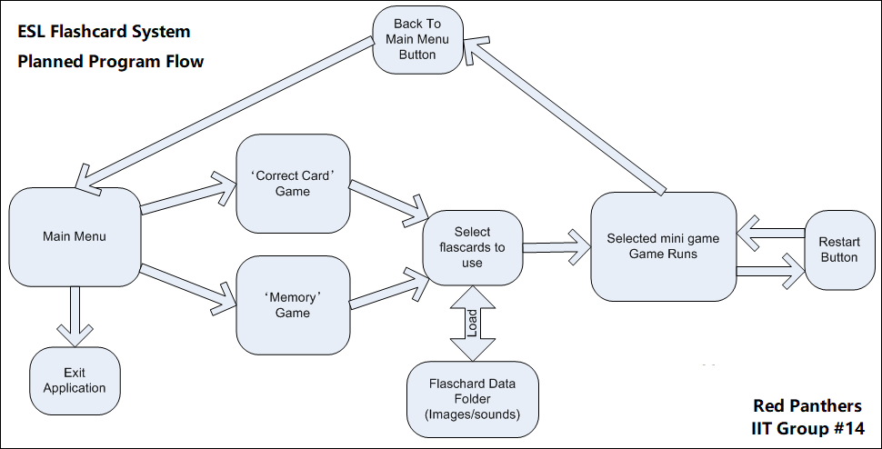

### Main Menu

The main menu will consist of three buttons:

* ‘Correct Card Game’
* ‘Memory Game’
* ‘Exit Application’

Clicking either of the game buttons will proceed to load up the selected mini-game, whereas the exit button will simply exit the application. The application will have an appropriate background image and a simple music loop.

### Flashcard Selection

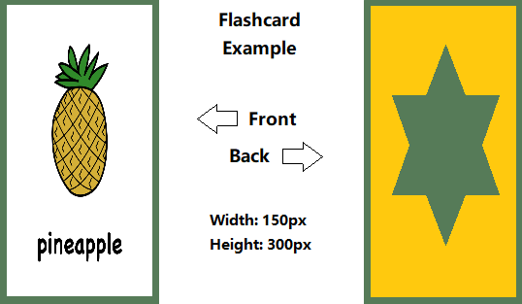The flashcard selection will have a large pane that will consist of all flashcards currently in the flashcard data folder. Each flashcard will have an audio file (.mp3) to show how the word is pronounced.

The user will have to select six flashcards. As the user clicks flashcards, they will turn green. Once the user has chosen six flashcards, they will continue to the game they previously selected.

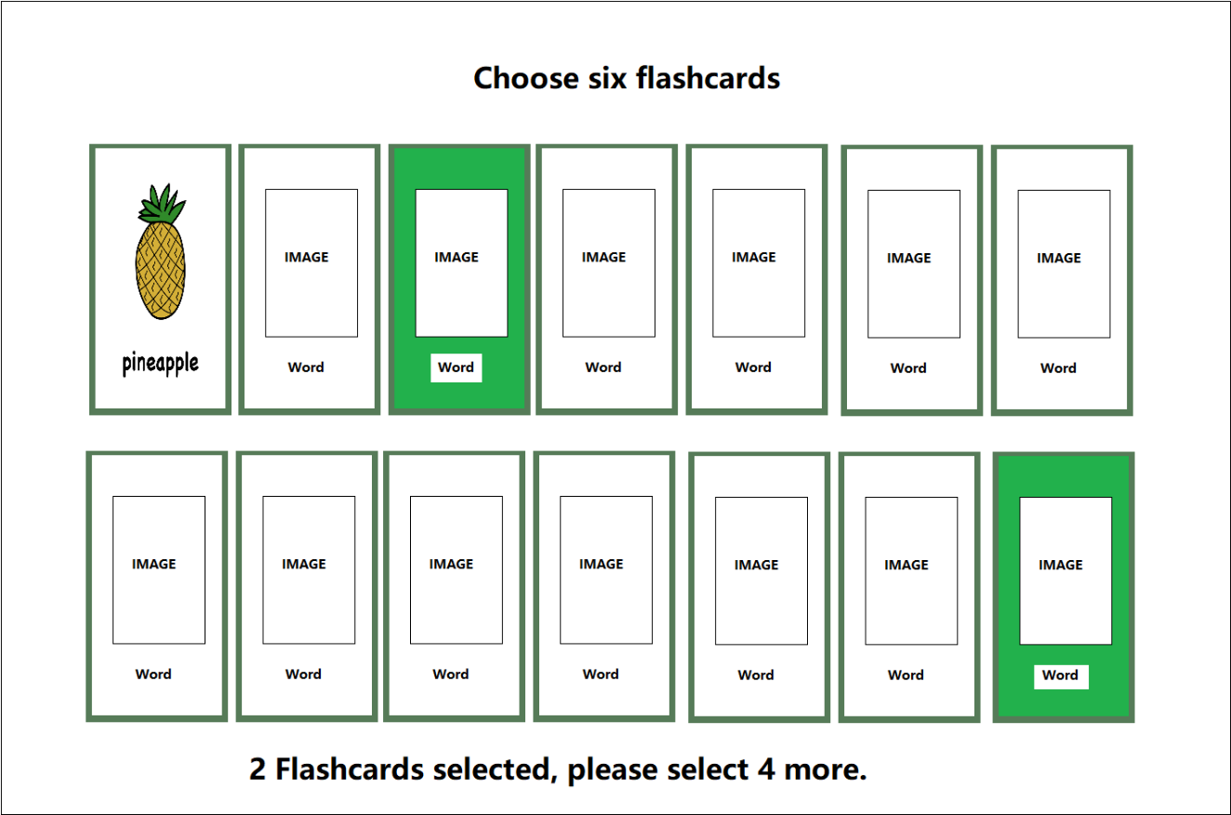

### Correct Card Game

A row of six flashcards will be displayed face up. The application pronounces one of the cards and the user then has 10 seconds to click on the matching flashcard. The user gets one point for a correct answer, or one point deducted for a wrong answer. The round will end when the application has finished reading all the flashcards. The game will not repeat the same flashcard twice.

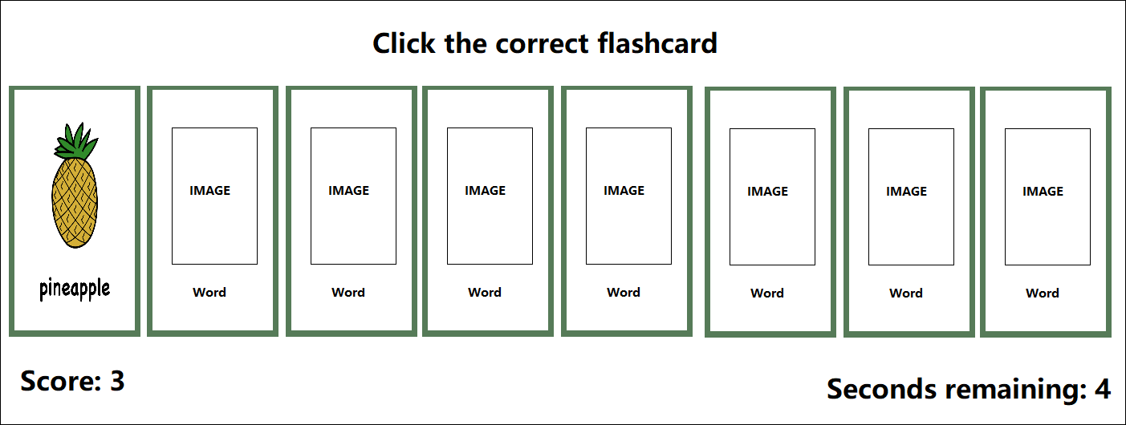

### Memory Game

A grid of flashcards is displayed, which is each of the six flashcards loaded twice, then distributed randomly on the screen. The flashcards are face down. The user will then click flashcards in pairs, looking for matches. As the card turns over, the audio plays. The user gets a point every time they fail to reveal a matching pair. The round ends when the user has matched all the pairs. The aim is to do it in the least number of moves, i.e. the lowest score.

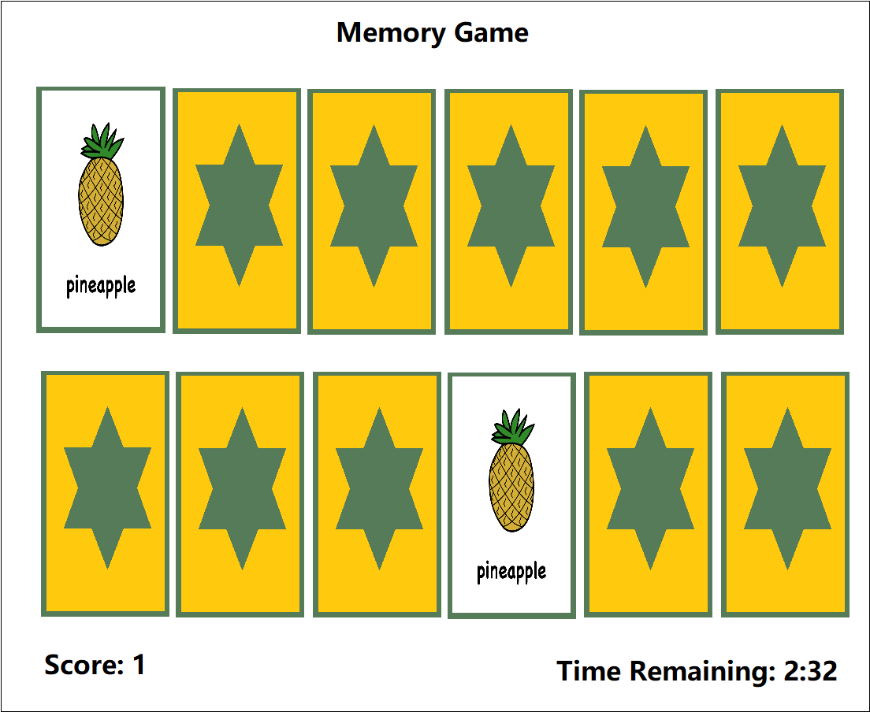

## Tools And technology:

The software required for this project will be Unity3d, Microsoft Visual Studio, Gimp photo manipulation suite. All this software is license-free for non-commercial use and so is acceptable to use for this project.

The hardware required for our group is a computer capable of running Unity3d and Microsoft Visual Studio, a microphone for recording audio and an internet connection so that we can collaborate online.

## Skills Required:

Our team will need to develop many skills to complete this project.

* programming skills to create the software in Unity3D
* graphic design skills to create the flashcards and backgrounds in Gimp or another suitable image manipulation software.
* Technical writing skills to create build documentation
* Creative writing skills to make clear, engaging instructions for users
* Liaison skills to engage consultants to work on making the game multi-lingual
* Video editing skills for presentation purposes,
* basic audio editing skills to create sounds for the flashcards and repeating background music
* project management skills to plan and manage the build
* leadership skills to help us stay focused and on task

## Outcome:

The outcome of this project will be the creation of a flashcard system to help children learn basic English words. The application will be a small but workable product that our team would be able to market on a standalone website or put on app stores.

Users will be able to add their own flashcards. This will empower the end-user to customise the app for use in ways that fit their particular ESL curriculum.

We hope that the software will be available for remote communities who don’t have high-end technology or qualified teachers to teach English.

## References Project idea

News 2020, "Vietnam lacks teachers to achieve language targets", *Thepienews.com*, 2020. [Online]. Available: https://thepienews.com/news/vietnam-teachers-language-targets/. [Accessed: 08- Jan- 2020].

Research, 2020, "English Language Learning Market to grow at 7.1% to hit $54.8 billion by 2025 – Insights on Recent Trends, Size, Share, Growth Opportunities, Key Developments and Future Outlook: Adroit Market Research", *GlobeNewswire News Room*, 2020. [Online]. Available: https://www.globenewswire.com/news-release/2019/07/26/1892347/0/en/English-Language-Learning-Market-to-grow-at-7-1-to-hit-54-8-billion-by-2025-Insights-on-Recent-Trends-Size-Share-Growth-Opportunities-Key-Developments-and-Future-Outlook-Adroit-Mar.html. [Accessed: 08- Jan- 2020].

Taylor, 2020, "People around the world still think English is the most valuable language to learn, study shows", *CNBC*, 2020. [Online]. Available: https://www.cnbc.com/2019/06/28/people-still-think-english-is-the-most-valuable-language-to-learn.html. [Accessed: 08- Jan- 2020].

# Group Reflections

## Anthony Brown

### What went well?

I believe we had a group of people that want to make a group work well and are prepared to work to that end. This was reflected in our ability to be decisive by sharing our opinions and then respecting the group consensus. Once a decision was made everyone effortlessly moved to the next work item.

### What could be improved?

I found our communication channels a bit stinted. We took a while to find the communication methods that suited the group. We could have been more productive in the middle part of the project. If we had got our communication working better earlier then we may have avoided this

### At least one thing that was surprising?

WE all occupy different time zones and work requirements. This didn’t cause nearly as much problems as I initially thought it might. Remote communication helped this process as members could pick up where the last had lest off.

### At least one thing that you have learned about groups?

Groups work best when everyone one is contributing.

## Tim Damon

### What went well?

The group was very well organised, using several different outlets for the organisation such as Trello, Slack, Discord and GitHub. Everyone picked up several parts of the project to complete themselves, agreeing to collaborate it all through GitHub. We had a clear list of tasks and who was assigned to what through the Trello board setup by Anthony.

### What could be improved?

Tasks assigned could be completed more quickly (myself included). More consistent group chats (through Discord) as we only got together a few times and it was never able to be all of us at once.

### At least one thing that was surprising?

How easy it was to organise everything with each person in the group without ever getting to meet face to face. Trello made creating a list of tasks and assigning them incredibly easy and that list was always there so you knew what needed doing and who was doing what.

### At least one thing that you have learned about groups?

That each individual putting in effort helps everyone else work load and that organisation is key, effective organisation can turn a large task into something much more manageable.

## Shaun Lottey

### What went well?

### What could be improved?

### At least one thing that was surprising?

### At least one thing that you have learned about groups?

## Jake McAndrew

### What went well?

I feel our group was very well organised, I’ve never used trello before, but it was a very useful tool to keep up to date on what needed to be done. Even though I found it very difficult to be online at the same time as the other group members due to my work schedule, I still feel like I always had clear direction on what needed to be done thanks to other team members.

### What could be improved?

I feel like the team worked pretty well together, the only major improvement I can see has to do with my personal time management and being more involved in group calls and discussions.

### At least one thing that was surprising?

One thing that was surprising was how organised and friendly everyone was. I have never done group work over the internet before and I was very surprised how smoothly everything went even with my limited time.

### At least one thing that you have learned about groups?

Group work is so much easier when everyone communicates and is organised

## Jason Tilgner

### What went well?

The team had some good organisation every was keen to get into the assignment, we probably didn’t have much of a structure at the start but Anthony was able to organise us and sort of become our team adviser. We used some different industry tools to be able to organise and set up a clear schedule, on who had to do what and when. Everyone was able to complete their part and make proper updates into GitHub. Some of the tools we used where trello, slack, and discord. It was also interesting to see everyone’s different industry views.

### What could be improved?

Just a bit of hesitation at the start to get tasks started and probably not spreading them out as late as we have. At some points it felt like it was taking a bit long on certain tasks.

### At least one thing that was surprising?

How easy and quick it was to organise everyone to get in communication to work out tasks and who was doing what. That everyone went off and did the task required, and generally above what was required. That members asking for each other opinions or asking for help if unsure, instead of just doing their own thing.

At least one thing that you have learned about groups?

That being organised at the start helps and that having helpful + willing team mates makes everything a lot smoother.

## Jason Walstab

### What went well?

What went well was the good organisation via Trello, an organisational online application, thanks to Anthony Brown. This allowed us to really focus on what we had to do as well as well have a clear list and direction on what we should be working on, who should be working on what and when things are done. Another highlight was the IT interview organised by Shaun Lottey which was very insightful as the IT professional we interviewed had great insights into the IT industry.

### What could be improved?

Meeting deadlines and getting work done faster, sometimes we seem to have been trailing at a slower pace than I would have liked, and the group work ended up being dragged out over a longer period than I thought we would get it done in.

### At least one thing that was surprising?

I was surprised at how effective it was to communicate and work online without the need for face to face interaction. In some ways it was more effective than working onsite in a team as we could easily post and share our documents in a central location.

### At least one thing that you have learned about groups?

I have learned that organisation is key and that the better organised we are as a team the faster work gets done, which in a way is more important than peoples individual skill level.

## Main Group Reflection:

Holding the group together has been out tools: GitHub, which we have used to combine all our resources, Trello, where we have meticulously planned our journey, Slack, which has been where we have done our chat groups, and our frequent meetings over discord when we were sick of typing.

These tools have really been the backbone for this group and have allowed us to work as a team regardless of distance or time zones. We believe that, without these tools the work would not have been possible. We all feel that what went well was the setting up of these tools from the start to ensure everyone could follow along and contribute as necessary. This allowed us to establish as clear workflow structure that we could all follow.

Coming from all different backgrounds, places, jobs, educational and technical levels we have managed to work well as a team mainly thanks to good organisational structure and a fair level of contribution among all our team members.

One area we feel we could have improved on is a more standard format for file contributions and uploads, as filenames and commit comments got a bit crazy towards the end with different versions of files in the GitHub repository and no common standard for commit comments or version numbers on documents. Towards the end it did get better as we organised the GitHub repository to better handle our documents and commits.

Something that was surprising was the spread of everyone's different skills and areas of expertise that helped us to gain insights from perspectives that we do not see for ourselves. This mix of different skills and experience did not result in conflicts among members, but instead really helped use work together.

The thing we have all learned is that communication is key in doing group projects, and the more communication we had the quicker we were able to finish off sections of the assignment. This was especially critical towards the end of the assignment, when we needed to start putting everything together into a single, workable project page.

We started off to a slow and rocky start but in the end have pulled through and hopefully have done an excellent job. All of us feel that together we have been able to manage this workload better than expected and are excited to move onto the main IT project side of things.